Feature Documentation

The Player
The player is loaded in at spawn point based on the loaded level and from their the user can move using wasd and shoot using the arrow keys. The player can also collect keys and use these to open door.
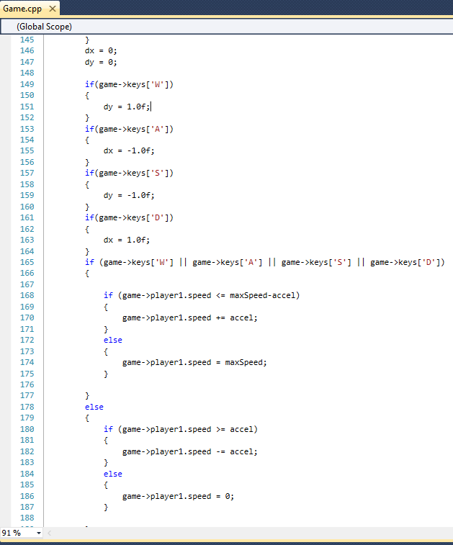
This code fields wasd and changes the velocity the player will move when player.move is run

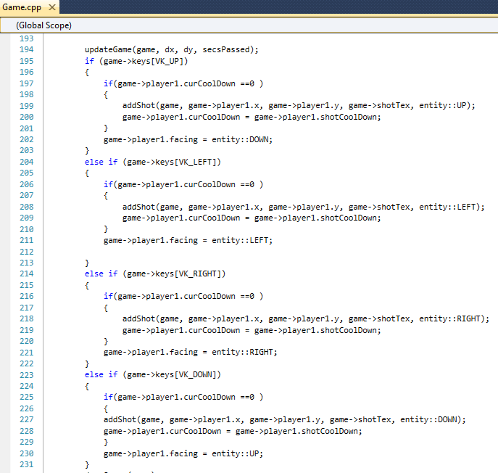
Fields the arrow keys and spawns a shot entity at the player facing in the direction of the arrow key. Shots move based on their initial direction and cannot change. There is a cooldown for shots so users have limited fire power

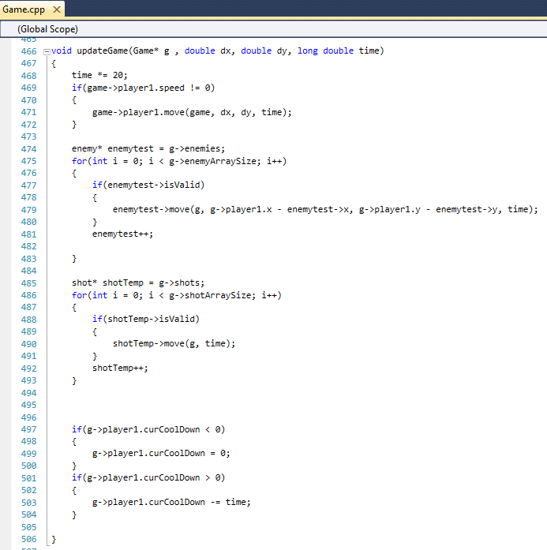
In update game we move the player, enemies and shots as well as cool down the players shot timer. In the game removed enemies are zeroed in the game array so the boolean isvalid will be false. This means only entities that have been initialised are rendered and collided.

Animation
Both enemies and the player are animated using 8 images(1 for each animation) that cycle when they move. The current frame is stored in their parent entity.
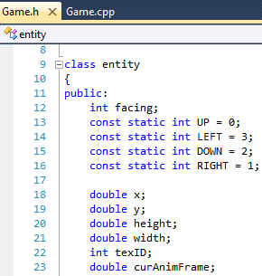
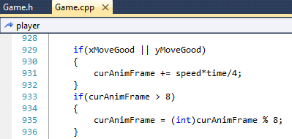
Right:
Declaration of current Animation frame
Above:
Update of current Animation frame. Called in player.move(shown above) and enemy.move
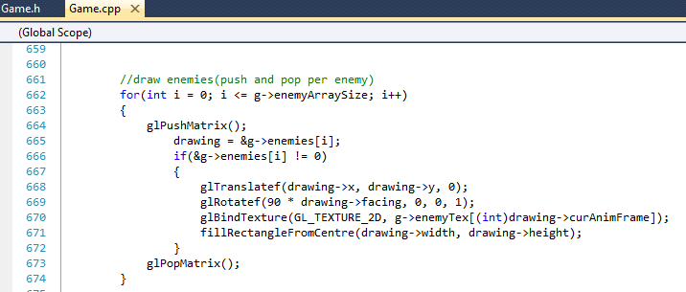
when drawing enemies (and player) the texture that is used is gotten from an array of texture handles using the truncated value of the current animation counter.
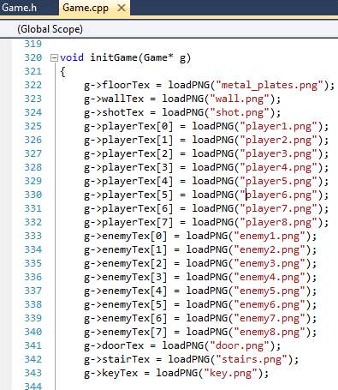
Textures are loaded in the init game function which is called before the start of the game loop. Static textures are stored as int and textures for animated entities are stoered in an int array.

Collision
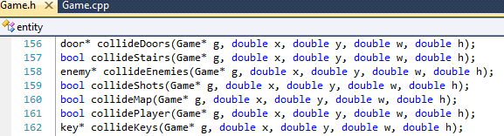
Collision is done using a collection of collide functions for each different type of object in the game(map, player, shots, enemies, doors and stairs).
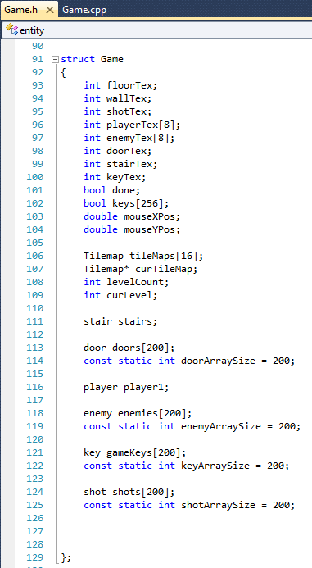
Collision with the map is done by integer dividing the passed x, y and x+w and y + h by the tilesize(16) and using the value to access the tile this x and y sit on. If the tile is denoted as filled the function returns true;
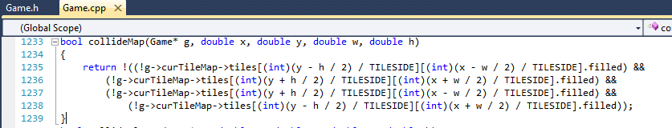
Collision with everything else is done using axis aligned bound boxes. Each collision method is largely the same but for instance if its enemies or keys it loops through all them and checks each but for player or stairs it doesn't need to loop as only one exists.
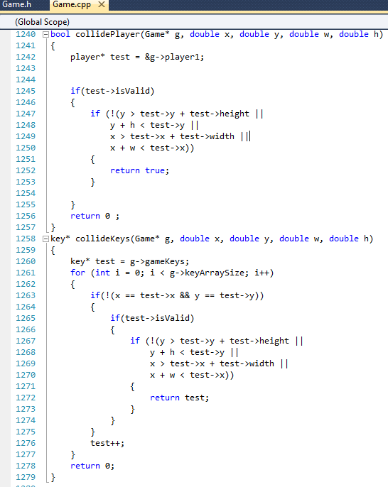

Acceleration
The players movement in the game is not instantaneous and despite it not taking long his speed does increase at the start of his movement.
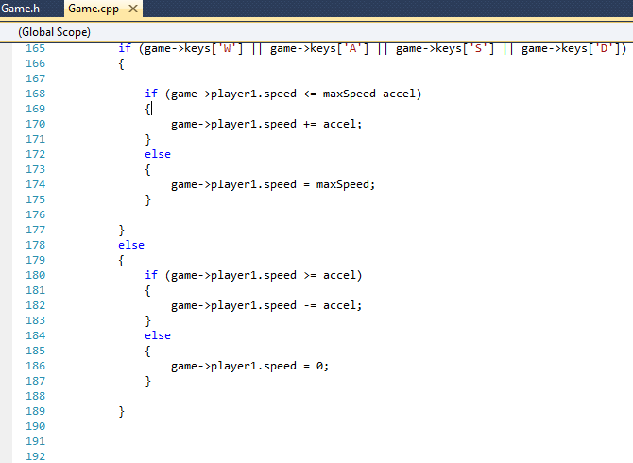
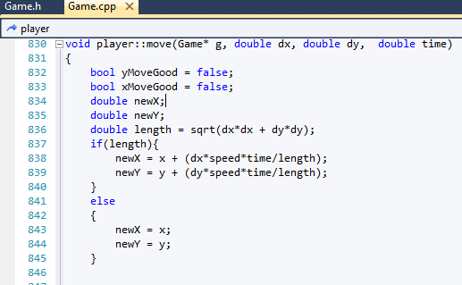

LevelSets and TileMaps
To make it easy to store levels in the filesystem each level is stored as a csv file using integers to denote what should be done for that tile(0 = floor, 1 = wall, 2 = floor + spawn enemy, 3 = floor + spawn player, 4 = floor + spawn door and 5 = floor + spawn stairs).
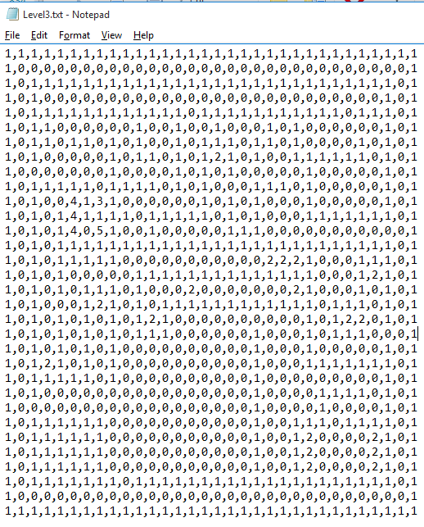
Levels are loaded into the game using the order found in levels.txt. The program to both find the tilemaps and work out the level order in the game. Changing the order in this file changes the order and you can als add and remove levels by editing this file.
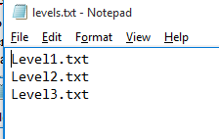

Level Editor
The level editor is copied from the source of the game with a few changes. The ai and movement code as been commented out or deleted and mouse controls added. Clicking on a tile increments its tile id mod 6 and then reloads the tilemap. When the user launches the editor they are presented with a tile map which is four walls and floor with nothing in it. Once the user has set up their tilemap they hit space and it writes the tile ids to a file called newLevel.txt which they can rename and add to levels.txt as explained before.

This game.cpp id editor/game.cpp where all above are Graphicsgame/game.cpp. Ill note whenever it is editor/game.cpp
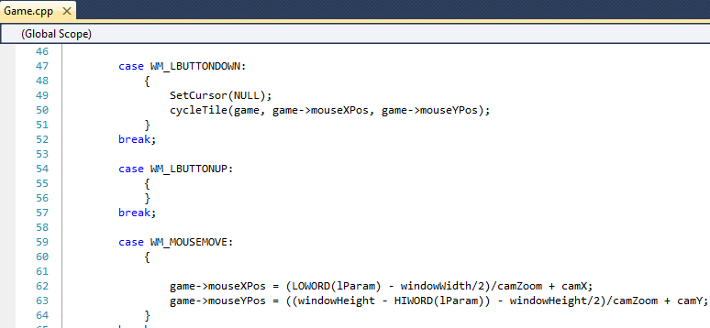
Mouse Controls
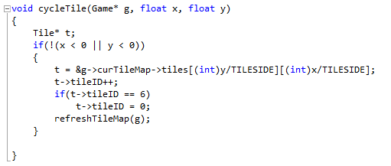
change tile id based on the ingame location of the users click

Time Stepping
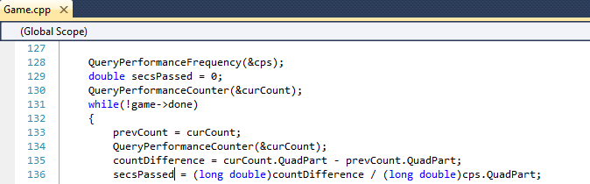
The seconds passed between frames is calculated at the start of each loop and used in the move functions of all the entities

Scoring
If a player finishes the game their score is the total number of keys they collected. This score ignores keys spent on doors. This score is presented upon reaching the end of the final level.
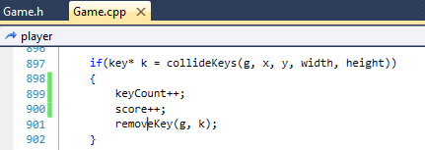
Add 1 to your score
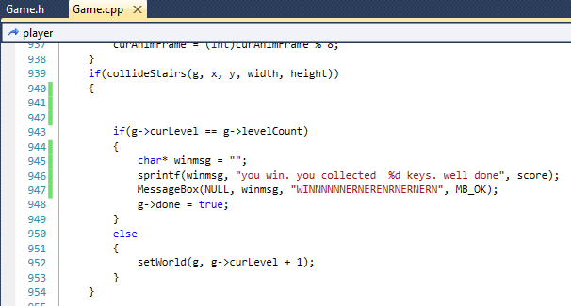
Display score when game finishes

